STAT 6340 Statistical and Machin Learning

Project 6

Buddhika Jayawardana

**Problem 1**

1. The data set contains 3 numerical variables; Mass, Period and Eccentricity of 101 observations. Following is the summery of the data set.

> summary(planet)

Mass Period Eccentricity

Min. : 0.050 Min. : 2.985 Min. :0.0000

1st Qu.: 0.930 1st Qu.: 44.280 1st Qu.:0.1000

Median : 1.760 Median : 337.110 Median :0.2700

Mean : 3.327 Mean : 666.531 Mean :0.2815

3rd Qu.: 4.140 3rd Qu.:1089.000 3rd Qu.:0.4100

Max. :17.500 Max. :5360.000 Max. :0.9270

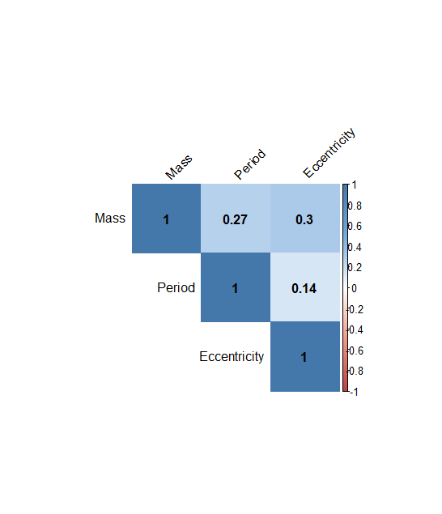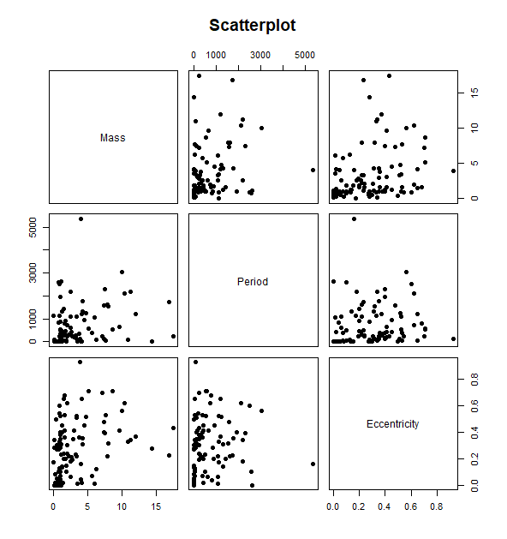

Three variables are ranged differently. Period has the largest range 2.985 - 5360.000 and Eccentricity has the smallest range 0 - 0.9270

Scatter plots show the correlations between the 3 variables, but their values are small.

1. Since the range of the period variable is too large compared to the other variables, its good to standardize them before doing any computations.

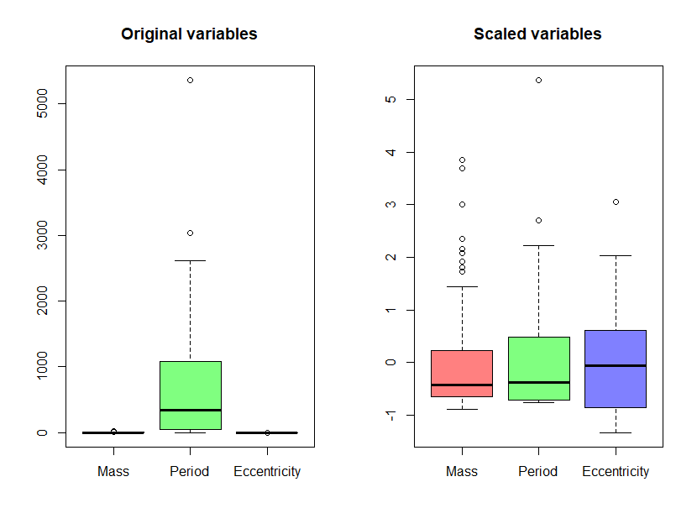

1. Since the variables are related to dynamics of the exoplanet bodies and the correlations between the variables are low its best to use metric-based distance to cluster the exoplanets.
2. 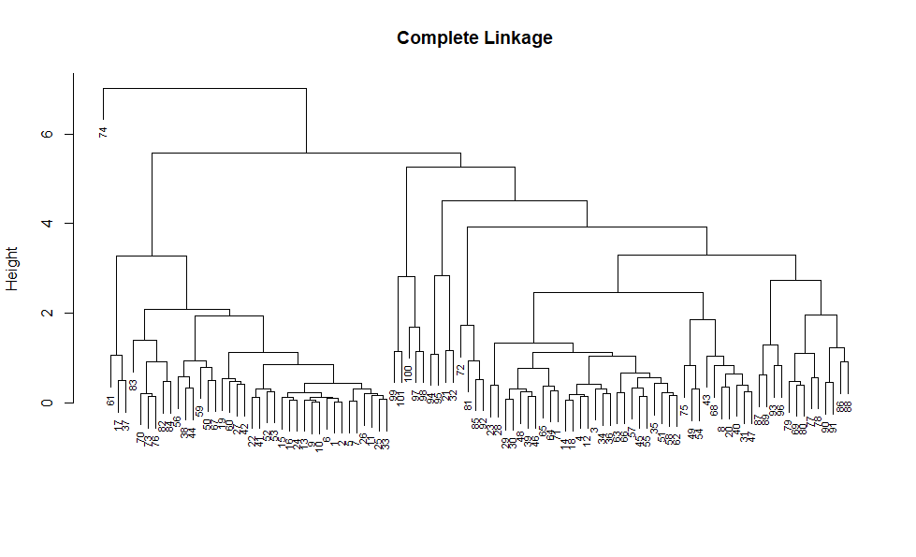Data is clustered hierarchically using complete linkage and Euclidean distance. Following is the dendrogram of the result.

Dendrogram gives 3 clusters as follows.

[1] 1 1 2 2 1 1 1 2 1 1 1 2 1 2 1 1 1 2 1 2 2 1 2 1 1 1 1 2 2 2 2 2 1 2 2 2

[37] 1 1 2 2 1 1 2 1 2 2 2 2 2 1 2 1 1 2 2 1 2 2 1 1 1 2 2 2 2 2 1 2 2 1 2 2

[73] 1 3 2 1 2 2 2 2 2 1 1 1 2 2 2 2 2 2 2 2 2 2 2 2 2 2 2 2 2

Summary of the cluster-specific means:

Group.1 Mass Period Eccentricity

1 1 1.703316 488.7479 0.07077105

2 2 4.311774 699.7941 0.41269355

3 3 4.000000 5360.0000 0.16000000

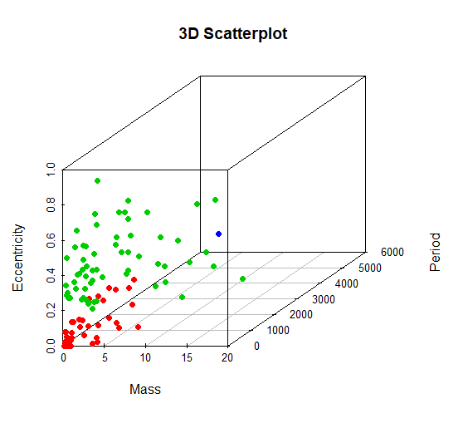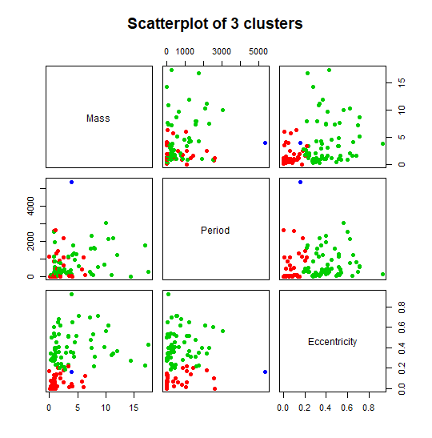

1. When the exoplanets are clustered with K-means, following results are found.

Cluster means:

Mass Period Eccentricity

1 2.734500 187.5163 0.2606221

2 5.390000 2767.2444 0.3283333

3 4.233333 1235.9729 0.3232917

Clustering vector:

[1] 1 1 1 1 1 1 1 1 1 1 1 1 1 1 1 1 2 1 3 1 2 1 3 1 1 1 1 3 1 1 1 3 1 1 1 1

[37] 2 3 1 1 1 1 1 3 1 1 1 1 3 3 1 1 1 3 1 3 1 1 3 1 2 1 1 1 1 1 3 1 3 1 1 1

[73] 1 2 3 1 3 3 3 3 1 1 3 1 1 3 1 2 1 3 3 1 1 2 2 1 2 3 1 3 1

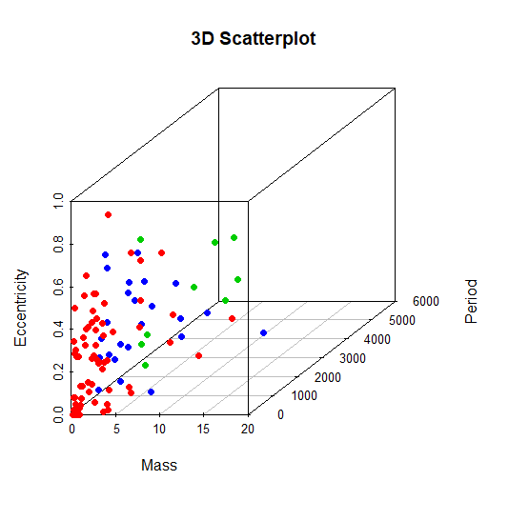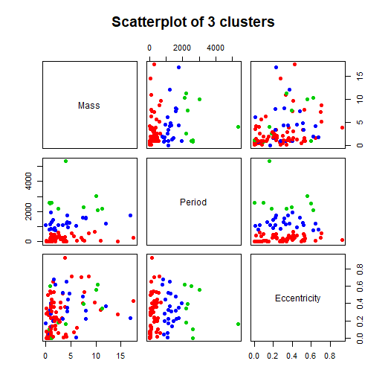

Since the Hierarchical clustering was able to cluster only one exoplanet for the 3rd cluster, K-means clustering works better when you need 3 clusters out of the data set. Also the pairwise scatterplots of the K-means shows somewhat clear separation of these three clusters.

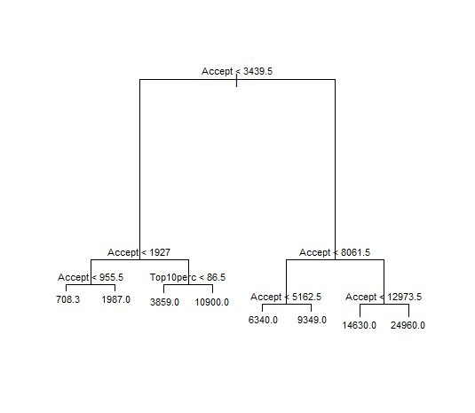

**Problem 2**

1. MSE = 2031000

|  |  |  |
| --- | --- | --- |
| Region | Expression | Mean(Predicted Applications) |
| 1 | Accept < 955.5 | 708.3 |
| 2 | 955.5 < Accept < 1927 | 1987.0 |
| 3 | 1927 < Accept and Top10per < 86.5 | 3859.0 |
| 4 | 1927 < Accept and Top10per > 86.5 | 10900.0 |
| 5 | 3439.5 < Accept < 5162.5 | 6340.0 |
| 6 | 3439.5 < Accept < 8061.5 | 9349.0 |
| 7 | 8061.5 < Accept < 12973.5 | 14630.0 |
| 8 | 12973.5 < Accept | 24960.0 |

1. When pruning is done for the tree, with LOOCV, best pruning size is found to be 8. Thus pruning is not useful for this tree and the pruned tree is exactly the same as the full tree. So is the MSE.

MSE of the pruned tree = 2031000

Most important predictors are Accept and Top10per

1. 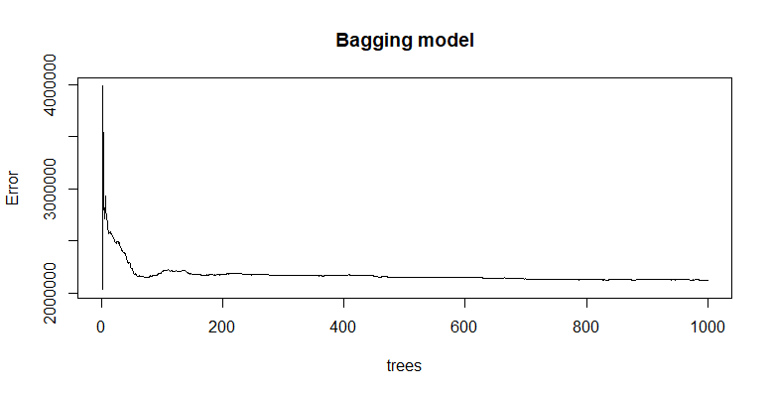Bagging approach has MSE = 2124209 and the top important predictor is Accept. Bellow are the top 5 important predictors.

X.IncMSE IncNodePurity

Accept 22016845.6518 10598466352

Top10perc 349136.3838 286343989

Enroll 295881.2979 245209919

Top25perc 188104.5242 161109658

Expend 122938.0253 88231957

After 200 trees, there is not much change in terms of error.

1. 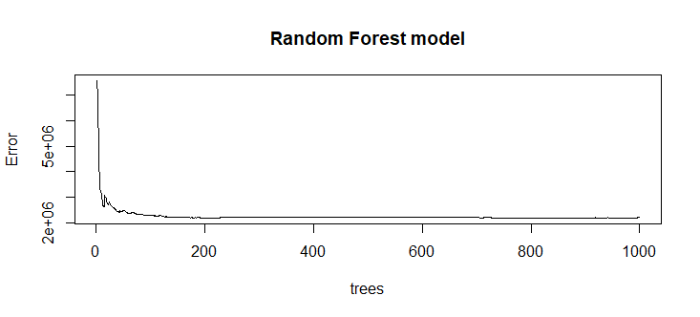Random forest approach has MSE = 2213661 and the top two important predictors are Accept and Enroll. Bellow are the top 5 important predictors.

X.IncMSE IncNodePurity

Accept 9357061.39 4787760962

Enroll 3622110.84 2533886881

F.Undergrad 2260502.82 1745082241

P.Undergrad 178029.66 369345190

Top25perc 302858.86 320552183

Again after 200 trees, there is not much change in terms of error.

1. 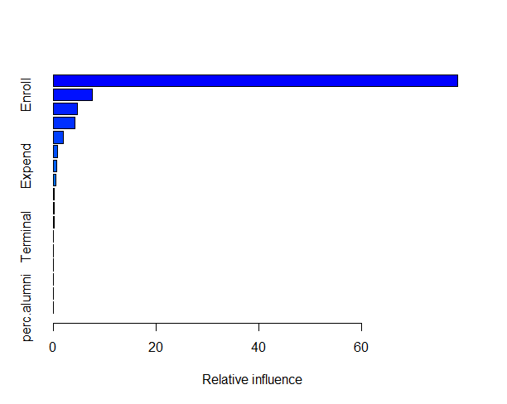Boosting approach has MSE = 3724476 and the top important predictor is Accept. Bellow are the top 5 important predictors.

var rel.inf

Accept Accept 78.79257671

Enroll Enroll 7.55712464

F.Undergrad F.Undergrad 4.68956879

Top10perc Top10perc 4.22216126

Top25perc Top25perc 2.01856968

1. Out of three methods, minimum MSE = 2124209 gives from Bagging method. Thus the best approach for this data set is Bagging method.

**Section 2**

# problem 1

planet <- read.csv("planet.csv", header = T)

attach(planet)

head(planet)

summary(planet)

# Mass Period Eccentricity

# Min. : 0.050 Min. : 2.985 Min. :0.0000

# 1st Qu.: 0.930 1st Qu.: 44.280 1st Qu.:0.1000

# Median : 1.760 Median : 337.110 Median :0.2700

# Mean : 3.327 Mean : 666.531 Mean :0.2815

# 3rd Qu.: 4.140 3rd Qu.:1089.000 3rd Qu.:0.4100

# Max. :17.500 Max. :5360.000 Max. :0.9270

library(corrplot)

plot(planet, main="Scatterplot", pch=19)

col <- colorRampPalette(c("#BB4444", "#EE9988", "#FFFFFF", "#77AADD", "#4477AA"))

corrplot(cor(planet), method="color", col = col(200),

type="upper",

addCoef.col = "black", # Add coefficient of correlation

tl.col="black", tl.srt=45, sig.level = 0.01, insig = "blank")

# part b)

# standardizing the data

planet.scaled <- scale(planet)

apply(planet.scaled, 2, mean)

apply(planet.scaled, 2, sd)

par(mfrow=c(1,2))

boxplot(planet, col = rainbow(3, s = 0.5), main="Original variables")

boxplot(planet.scaled, col = rainbow(3, s = 0.5), main="Scaled variables")

par(mfrow=c(1,1))

# part d)

# hierarchical cluster using complete linkage and Euclidean distance.

hc.complete <- hclust(dist(planet.scaled), method = "complete")

plot(hc.complete, main = "Complete Linkage", xlab = "", sub = "",

cex = 0.7)

hc.clusters <- cutree(hc.complete, 3)

# [1] 1 1 2 2 1 1 1 2 1 1 1 2 1 2 1 1 1 2 1 2 2 1 2 1 1 1 1 2 2 2 2 2 1 2

# [35] 2 2 1 1 2 2 1 1 2 1 2 2 2 2 2 1 2 1 1 2 2 1 2 2 1 1 1 2 2 2 2 2 1 2

# [69] 2 1 2 2 1 3 2 1 2 2 2 2 2 1 1 1 2 2 2 2 2 2 2 2 2 2 2 2 2 2 2 2 2

a <- cbind(planet,hc.clusters)

aggregate(a[, 1:3], list(a$hc.clusters), mean)

# Group.1 Mass Period Eccentricity

# 1 1 1.703316 488.7479 0.07077105

# 2 2 4.311774 699.7941 0.41269355

# 3 3 4.000000 5360.0000 0.16000000

library(scatterplot3d)

scatterplot3d(Mass, Period, Eccentricity, color = (hc.clusters + 1), main="3D Scatterplot", pch = 16)

plot(planet, main="Scatterplot of 3 clusters", col = (hc.clusters + 1), pch=19)

# part e)

set.seed(3)

km.out <- kmeans(planet, 3, nstart = 20)

# K-means clustering with 3 clusters of sizes 68, 9, 24

# Cluster means:

# Mass Period Eccentricity

# 1 2.734500 187.5163 0.2606221

# 2 5.390000 2767.2444 0.3283333

# 3 4.233333 1235.9729 0.3232917

#

# Clustering vector:

# [1] 1 1 1 1 1 1 1 1 1 1 1 1 1 1 1 1 2 1 3 1 2 1 3 1 1 1 1 3 1 1 1 3 1 1 1 1

# [37] 2 3 1 1 1 1 1 3 1 1 1 1 3 3 1 1 1 3 1 3 1 1 3 1 2 1 1 1 1 1 3 1 3 1 1 1

# [73] 1 2 3 1 3 3 3 3 1 1 3 1 1 3 1 2 1 3 3 1 1 2 2 1 2 3 1 3 1

#

# Within cluster sum of squares by cluster:

# [1] 2526577 8224052 2492267

# (between_SS / total_SS = 82.7 %)

scatterplot3d(Mass, Period, Eccentricity, color = (km.out$cluster+ 1), main="3D Scatterplot", pch = 16)

plot(planet, main="Scatterplot of 3 clusters", col = (km.out$cluster+ 1), pch=19)

# problem 2

library(ISLR)

train.data <- College

str(train.data)

attach(train.data)

# part a)

library(tree)

tree.College <- tree(Apps ~ ., train.data)

# node), split, n, deviance, yval

# * denotes terminal node

#

# 1) root 777 1.162e+10 3002.0

# 2) Accept < 3439.5 651 1.732e+09 1736.0

# 4) Accept < 1927 532 3.251e+08 1182.0

# 8) Accept < 955.5 335 3.457e+07 708.3 *

# 9) Accept > 955.5 197 8.769e+07 1987.0 *

# 5) Accept > 1927 119 5.130e+08 4213.0

# 10) Top10perc < 86.5 113 1.883e+08 3859.0 *

# 11) Top10perc > 86.5 6 4.255e+07 10900.0 *

# 3) Accept > 3439.5 126 3.461e+09 9541.0

# 6) Accept < 8061.5 101 6.351e+08 7770.0

# 12) Accept < 5162.5 53 1.439e+08 6340.0 *

# 13) Accept > 5162.5 48 2.632e+08 9349.0 *

# 7) Accept > 8061.5 25 1.229e+09 16700.0

# 14) Accept < 12973.5 20 1.172e+08 14630.0 *

# 15) Accept > 12973.5 5 6.849e+08 24960.0 *

summary(tree.College)

# Regression tree:

# tree(formula = Apps ~ ., data = train.data)

# Variables actually used in tree construction:

# [1] "Accept" "Top10perc"

# Number of terminal nodes: 8

# Residual mean deviance: 2031000 = 1.562e+09 / 769

# Distribution of residuals:

# Min. 1st Qu. Median Mean 3rd Qu. Max.

# -8371.0 -429.3 -104.3 0.0 286.7 23140.0

plot(tree.College)

text(tree.College, pretty = 0, cex = 0.7)

# part b)

cv.College <- cv.tree(tree.College, FUN = prune.tree, K=777)

# $size

# [1] 8 7 6 5 4 3 2 1

#

# $dev

# [1] 2381430909 2667272688 3129789615 3196896546 3251213689

# [6] 4065549912 5778625446 12478016777

#

# $k

# [1] -Inf 202873515 228050501 282105525 426616632 893815939

# [7] 1596851915 6430760151

#

# $method

# [1] "deviance"

#

# attr(,"class")

# [1] "prune" "tree.sequence"

plot(cv.College$size, cv.College$dev, type = "b")

# get the best size

cv.College$size[which.min(cv.College$dev)]

# [1] 8

prune.College <- prune.tree(tree.College, best = 8)

summary(prune.College)

# Regression tree:

# tree(formula = Apps ~ ., data = train.data)

# Variables actually used in tree construction:

# [1] "Accept" "Top10perc"

# Number of terminal nodes: 8

# Residual mean deviance: 2031000 = 1.562e+09 / 769

# Distribution of residuals:

# Min. 1st Qu. Median Mean 3rd Qu. Max.

# -8371.0 -429.3 -104.3 0.0 286.7 23140.0

plot(prune.College)

text(prune.College, pretty = 0)

# part c)

library(randomForest)

set.seed(1)

bag.College <- randomForest(Apps ~ ., data = College, mtry = 17,

ntree = 1000, importance = TRUE)

# Call:

# randomForest(formula = Apps ~ ., data = College, mtry = 17, ntree = 1000, importance = TRUE)

# Type of random forest: regression

# Number of trees: 1000

# No. of variables tried at each split: 17

#

# Mean of squared residuals: 2124209

# % Var explained: 85.8

bag.imp <- data.frame(bag.College$importance)

bag.imp[order(bag.imp$IncNodePurity, decreasing = T),]

# X.IncMSE IncNodePurity

# Accept 22016845.6518 10598466352

# Top10perc 349136.3838 286343989

# Enroll 295881.2979 245209919

# Top25perc 188104.5242 161109658

# Expend 122938.0253 88231957

plot(bag.College, main = "Bagging model")

# part d)

set.seed(1)

forest.College <- randomForest(Apps ~ ., data = College, mtry = 6,

ntree = 1000, importance = TRUE)

# Call:

# randomForest(formula = Apps ~ ., data = College, mtry = 6, ntree = 1000, importance = TRUE)

# Type of random forest: regression

# Number of trees: 1000

# No. of variables tried at each split: 6

#

# Mean of squared residuals: 2213661

# % Var explained: 85.2

forest.imp <- data.frame(forest.College$importance)

forest.imp[order(forest.imp$IncNodePurity, decreasing = T),]

# X.IncMSE IncNodePurity

# Accept 9357061.39 4787760962

# Enroll 3622110.84 2533886881

# F.Undergrad 2260502.82 1745082241

# P.Undergrad 178029.66 369345190

# Top25perc 302858.86 320552183

plot(forest.College, main = "Random Forest model")

# part e)

library(gbm)

set.seed(1)

boost.College <- gbm(Apps ~ ., data = College, distribution = "gaussian",

n.trees = 1000, interaction.depth = 1, shrinkage = 0.01, cv.folds = 777)

# gbm(formula = Apps ~ ., distribution = "gaussian", data = College,

# n.trees = 1000, interaction.depth = 1, shrinkage = 0.01,

# cv.folds = 777)

# A gradient boosted model with gaussian loss function.

# 1000 iterations were performed.

# The best cross-validation iteration was 999.

# There were 17 predictors of which 14 had non-zero influence.

summary(boost.College)

# var rel.inf

# Accept Accept 78.79257671

# Enroll Enroll 7.55712464

# F.Undergrad F.Undergrad 4.68956879

# Top10perc Top10perc 4.22216126

# Top25perc Top25perc 2.01856968

# P.Undergrad P.Undergrad 0.88111834

mean(boost.College$cv.error)

# [1] 3724476